www.sxtrader.net
1/7/2013
Manual SXTrader
Version 2.0

Version 2.0
Table of Content
Foreword 3
Acknowledgement 3
Source of Download & Installation 4
Download 4
Installation 5
Updates 8
Starting SXTrader 10
Main User Interface 12
Titlebar 12
Menu 12
Modul Tree 13
Module View 13
Message Window 13
Statusbar 13
Account Balance 13
Liveticker State 13
Common Configuration 13
Liveticker Interval 14
Sport Exchange Interval 14
Confirm Fast Bets 14
Debug Information 14
Logging 15
Log Liveticker 15
Log Trades 15
Log Bet Amounts 15
Statistics & analyses 16
Match List 16
Default Color Schemes & Information Icons 17
Customer Defined Color Schemes 18
Manual Liveticker Connection 23
View Historic Data 25
View Match Details 26
View Extended Statistics 27
Score Matrix 28
Win/Loss/Draw 30
Over/Under 31
Liveticker Mapping 33

Foreword
SXTrader is a bot for automated trading on soccer markets at sport exchanges.
The current version 2.0 of SXTrader supports the sport exchanges Betfair and Betdaq.
SXTrader is Freeware. This means the user does not have to pay for the usage of SXTrader in any form. But the programmer of SXTrader is asking for support because he is paying the website and the database servers with his own money.
There are two ways to support the developer: The first one is to hit the donation button at the startup of SXTrader. The second one is to sign up at websites via the banners on www.sxtrader.net .

Acknowledgement
I want to special thank the user “Kites”. He wrote the original manual for SXTrader. Without him there won’t be a manual today as I as the most developers have an aversion to document my work.

Source of Download & Installation

Download
SXTrader can be downloaded at http://www.sxtrader.net.
At the web page of SXTrader you have to click the Item “Download SXTrader” on the left side. This will redirect you to the download page.
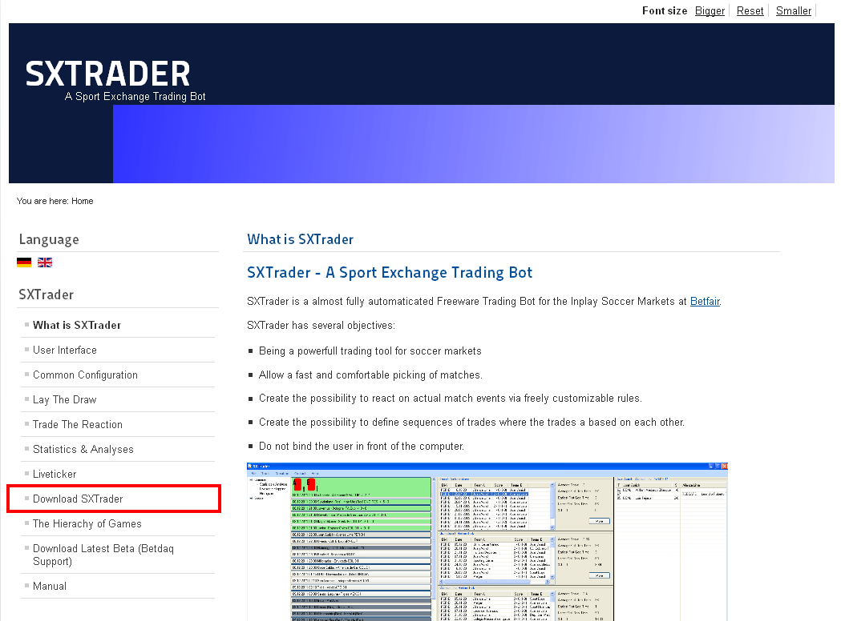
Figure 1: Link to the download page of SXTrader
At the Download Page you can either download the standard version of SXTrader or a special version for Windows 64-bit systems.
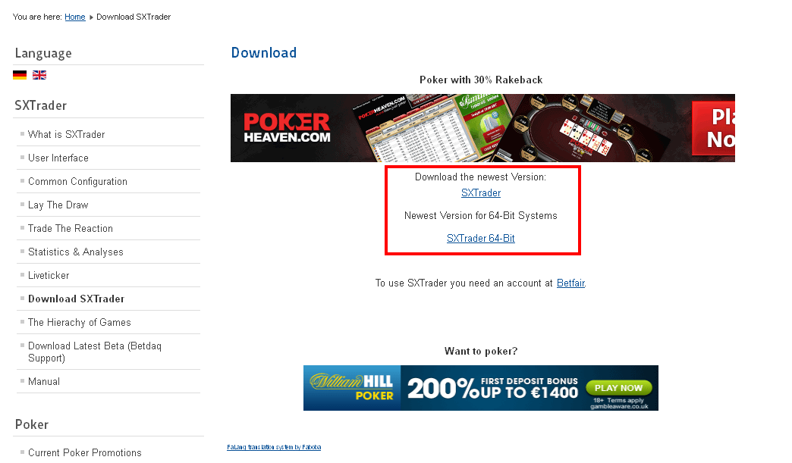
Figure 2: Download link of the different SXTrader versions

Installation
After the download there should be a file called SXTrader.exe or SXTrader64.exe in your download folder.
Now this file has to be executed. To execute just double click on the file name. This starts the extraction program for the installation files. At the extraction programe you can define where to extract the files.
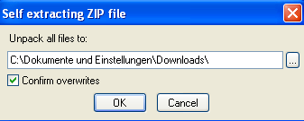
Figure 3: Extractor for Installation Files
After the extractor has finished the file “setup.exe” in the directory where the files have been extracted has to be executed. This will start the installer of SXTrader.
You can confirm the first dialog window of the setup wizzard with pressing the button “Next”.
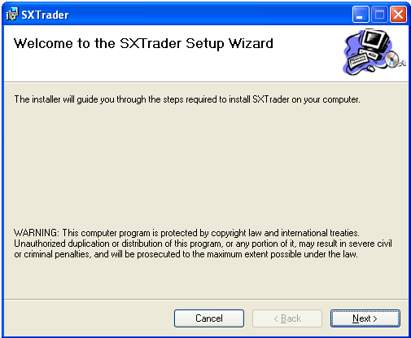
Figure 4: Setup Wizzard Page 1
At the second dialog the destination directory for this installation can be changed. Usually the suggested value is accepted with pressing the button “Next”.
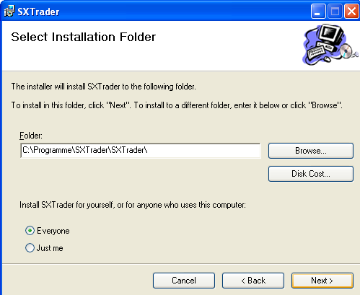
Figure 5: Setup Wizzard Page 2
The third dialog is just for confirming. If the button “Next” is pressed then SXTrader will be installed at the given directory.
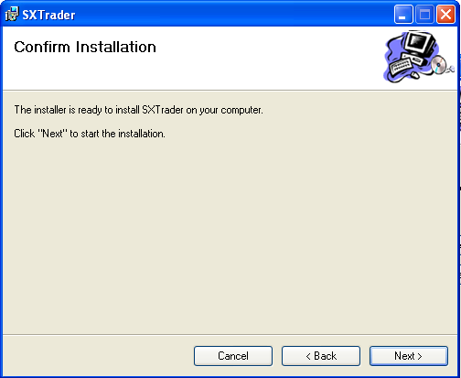
Figure 6: Setup Wizzard Page 3
After the installation there should be a start menu entry and a desktop icon called SXTrader.

Updates
At startup SXTrader checks if there is a new version available. If this is the case a dialog with update informations will be displayed.
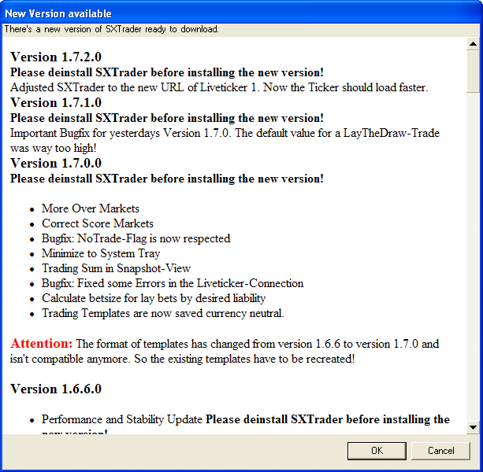
Figure 7: Dialog with update informations
SXtrader will only be runable with the latest version!
With clicking the button “OK” a webbrowser is opened with the download page. When clicking the Button “Cancel” the update will be declined and SXTrader will shut down.
SXTrader Version 1 will be runable independendly from version 2 but there will not be any new updates as it has reached it end of life.
Before installing a new version please deinstall the old one first!

Starting SXTrader
SXTrader is started by selecting the appropiate start menu entry or by double click on icon of SXTrader at the desktop.
If no new update is available (see Updates) an information dialog is shown. In this dialog you have the possibility to donate SXTrader. There will also be a window with interesting news and advertising.
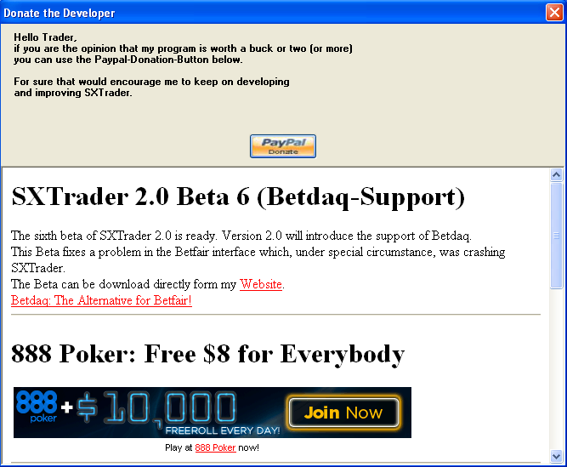
Figure 8: Starting Dialog with informations
You can close this dialog by pressing the red X in the top right corner.
Now the sport exchange login dialog is displayed.
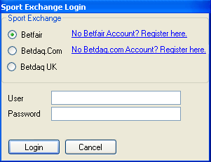
Figure 9: Sport Exchange Login Dialog
First the sport exchange where to log in has to be choosen. The selection is Betfair, Betdaq.com and Betdaq.co.uk. If you don’t have an account at the choosen sport exchange but want to open one you can click the link right of the sport exchange name. Now the web browser with the registration page of the sport exchange will be opened.
Betdaq.com and Betdaq.co.uk are two different entities with own user and passwords. You can have accounts on both.
After choosing the sport exchange you have to input your username and password into the input fields. After clicking the button “Login” your login data will be send to the sport exchange. If an error occurs a message with the description of the error will be displayed. Otherwise the main user interface of SXTrader is loaded.
With pressing “Cancel” the login process is aborted and SXTrader is closed.
SXTrader will not save any passwords and is transfering the login data exclusivly to the sports exchange only.
SXTrader will also not collect any kind of data which could identify a user and transfer it to the SXTrader Server or any other third party.

Main User Interface
After a successful login the main user interface of SXTrader will be loaded.
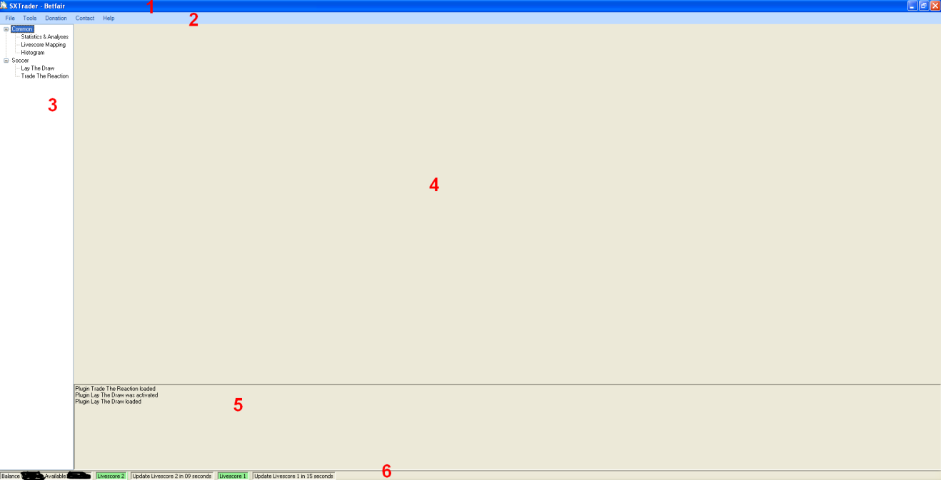
Figure 10: Main User Interface of SXTrader
The User Interface has several segments:
- Titlebar
- Menu
- Modul Tree
- Modul View
- Message Window
- Statusbar

Titlebar
At the titlebar the name “SXTrader” + <Name of logged in sport exchange> is displayed.

Menu
- File
  - Exit: Closes SXTrader
- Tools
  - Configuration: Opens the configuration dialog of SXTrader
- Donation: Opens a webbrowser window with the paypal donation page
- Contact
  - Report Bug: Opens the mail client with the email address for reporting a bug
  - Make a Suggestion: Opens the mail client with the email address for makin a suggestion regarding SXTrader
- Help: Opens a webbrowser with www.sxtrader.net

Modul Tree
Here all available Moduls of SXTrader will be displayed.

Module View
If a modul is selected at the Modul Tree its User Interface will be shown here.

Message Window
At the message window all relevant news about trades and bets will be displayed

Statusbar
The statusbar is informing the user about his account balance and the state of the liveticker connections.

Account Balance
The first left element of the statusbar is the account balance. It is updated every minute. It contains followin elements:
- Balance: The overall balance of the account
- Available: The amount of money available for bets.

Liveticker State
There is an item for every connected liveticker which displays the state of it and a countdown until the next actualization of the ticker data.If the name of the ticker has a green background then all is up and well. If the background is red then there was an error during the last update.

Common Configuration
Common Configuration are the settings of SXTrader which are not exclusivly for a module but have effects on the whole application.
The Common Configuration can be found via this menu path: Tools→Options→Configuration→General
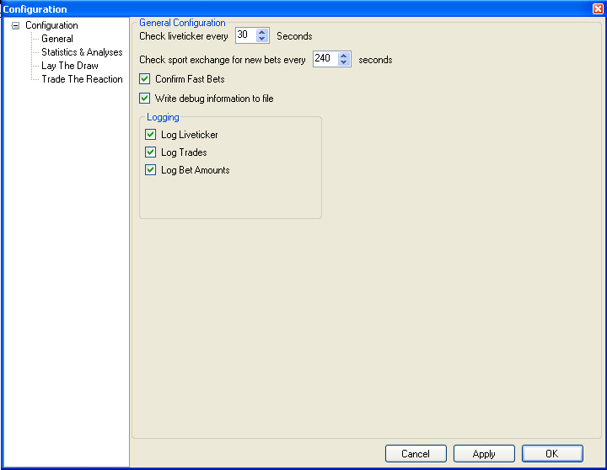
Figure 11: Common Configuration Dialog SXTrader

Liveticker Interval
The value “Check liveticker every <x> Seconds” defines the time that have to pass before checking the liveticker for new informations (e.b. Goals, Red Cards, Match Begin; Match End).

Sport Exchange Interval
The value “Check sport exchange for new bets every <x> seconds> defines the time that have to pass before checking the sport exchange for new unknown or updated bets. This feature is only a fall back solution. Usually a Trade in SXTrader controls and keeps its own bets under watch itself.

Confirm Fast Bets
If this checkbox is set then a confirmation question is displayed in a message box before placing a Fast Bet with SXTrader.

Debug Information
If this checkbox is set then a file named DebugOutput.txt will be created in the base directory of SXTrader.

Logging
The logging feature, unlike the debug information, is creating a file for each match. The files will be created in the directory \logs\<logginmodule> of the base directory. The name of the logging file will always have following format: <Team A>_<Team B>.xml. The logging files will be stored for two days. Afterwards SXTrader will delete older files automatically.
Usually it is not neccessary to have the Debug Information and the Liveticker Logs activated.
But if you suspect an error you should activate them.
The Default settings of SXTrader after Installation will have the logging deactivated.

Log Liveticker
If this checkbox is set then a file will be created for each match which has a connection between liveticker and sport exchange. The storage place for this file is \logs\liveticker. Within the file all signals of the liveticker regarding the match will be stored.

Log Trades
If this checkbox is set then a file will be created for each match where a bet or a trade rule exists. The file will be stored under \logs\trades. Within the file all information about the decission processes of a trade will be stored.

Log Bet Amounts
To protect the privacy of its User SXTrader does not store information about the bet amounts by default.
If this checkbox is set the information of the bet amounts will be stored in the Trade Logs.

Statistics & analyses
The Module Statistics & Analyses is the C&C-Center of the trading on Soccer Markets with SXTrader.
At the Module Tree you can find it at Common→Statistics & Analyses.
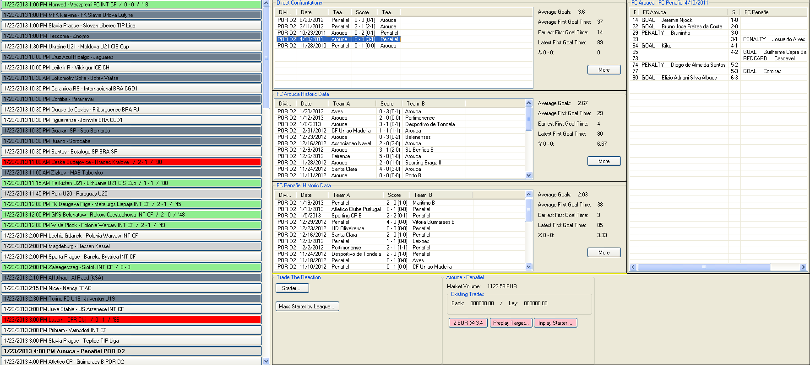
Figure 12: A Complete view on the module Statistics & Analyses
The Module Statistics & Analyses contains several segments. On the left side there is the match list with the inplay matches for the next 24 hours. In the middle there are the historic data lists. On the right side there is the detail view for match events of a historic match. On the Button there is the Fast Bet- and Rulesetarea of the different trading modules of SXTrader.

Match List
The match list is displaying the inplay matches of the next 24 hours. To give the user a better overview there are several different color schemes and information icons.
An unstarted match is displaying following informations: Date and time of match begin – Name of the teams – League or Tourney.
Figure 13: Display of a match before start
If the match has started the information are changing to following: Date and time of match begin – Name of Teams – League or Tourney – Score – Playtime.
Figure 14: Display of a running match
If the match has ended the information are changing to following: Date and time of match begin – Name of Teams –League or Tourney – Final Score.
Figure 15: Display of an ended match

Default Color Schemes & Information Icons
SXTrader contains some default color schemes and information icons to allow the user a quick overview of the state of a match.
If a match as no liveticker conection then the match will be displayed with a dark grey blackground.
Figure 16: Match with no liveticker connection
If a match has just a single liveticker connection then the background will be middle grey.
Figure 17: Match with a single liveticker connection
If a match is connected with both liveticker then the background will be light grey.
Figure 18: Match with both liveticker connections
If a match is running then the background will be green.
Figure 19: Running match
If a match has ended then the background will be red.
A coloring if a match is running or hast ended is only possible if at least one liveticker is connected
Figure 20: Ended match
If a red card will be given to a team in a match and the information about it will be passed by the livetickers SXTrader will display an according information icon at the match. An “A” on the Icon means that this is the red card count for the home team. A “B” on the icon means that this is the red card count for the away team.
If both teams have red cards then two icons will be displayed.

Figure 21: Information icons red cards
If at least one trading module is active on the match then an according icon will be displyed. The meaning of the icons will be explained in the chapters of said modules.

Figure 22: Information icons Trades

Customer Defined Color Schemes
To give the user the possibility quickly, especially on days with a high number of inplay matches, identify matches of interest SXTrader offers the feature to color a match in an individual color if a statistical ruleset is matched.
The dialog for customer defined color schemes can be called in the following way: Tools→Options→Configuration→Statistics & Analyses→Game Coloring.
By default there are no customer defined color schemes after the installation of SXTrader.
With pressing the button “New” a new Rule will be created.
The usage of colors which are already used by SXTrader for other purposes should be avoided.
Otherwise the match list could be misleading.

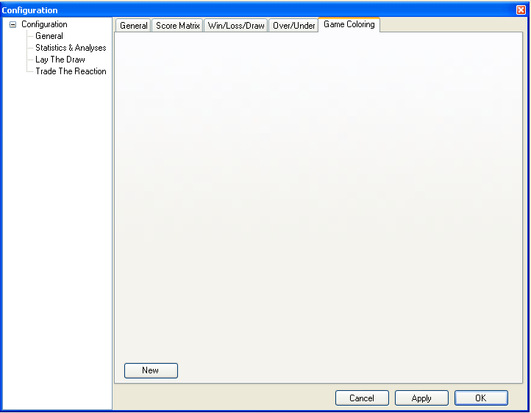
Figure 23: Dialog Customer Defined Color Schemes – Without Rules
Now a new rule definition is shown in the dialog.In the next step a color is selected in which a match at the match list is colored if the rule applies.
It is recommend to add every rule a check for number of data.
This ensures that the colorselection is meaningful.
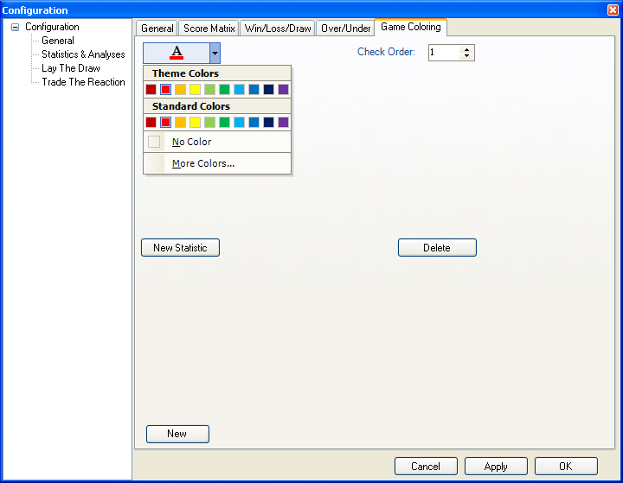
Figure 24: Dialog Customer defined color scheme – New rule – Color selection
After selecting a color a new check value is created by pressing the button “New Statistic”.
Now a statistic is created which has to apply if a match should be displayed with the selected color.To do so several different values have to be selected.
- Team selection
  - Both Teams: Only use data from direct confrontations.
  - Team A: Only use data from the home team.
  - Team B: Only use data from the away team.
- Home / Away Selection
  - Home and Away: Use data from both home and away matches. In case of “Both Teams” this is always from the viewpoint of the home team of the current match.
  - Home: Use data from home matches only. In case of “Both Teams” this is always from the viewpoint of the home team of the current match.
  - Away: Use data from away matches only. In case of “Both Teams” this is always from the viewpoint of the home team of the current match.
- Statistic: The statistic the selection should be applied on.
After the kind of data and the statistic to use was defined the value range to apply has to be defined.
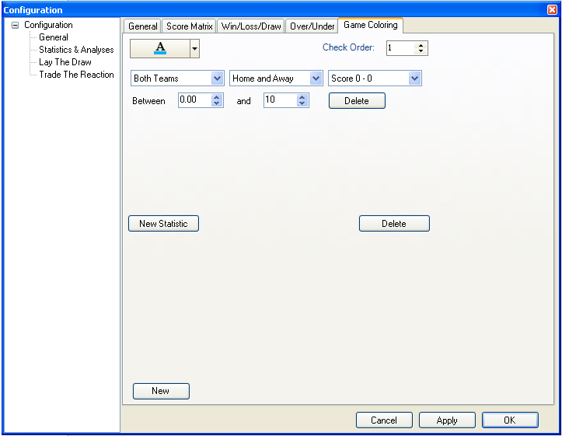
A newly defined customer color scheme first applies after SXTrader is restarted.
Figure 25: Dialog customer defined color scheme – New rule – New statistic
If several customer color schemes have been defined then there also have to be a check order. SXTrader is iterating through the customer color schemes rules in that defined check order until it has pass through all rules or have found a match.
With pressing the button “Apply” or “OK” a rule is stored.

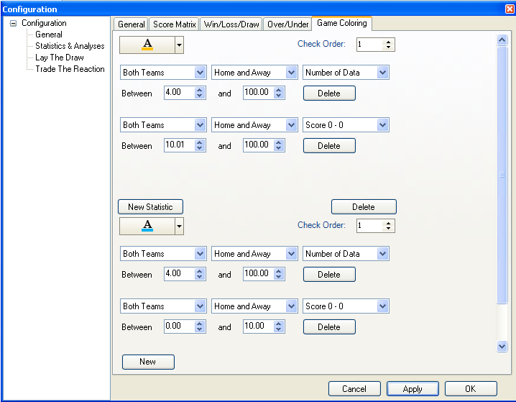
Figure 26: Dialog customer defined color scheme – Example of a more complex rule
Customer defined color schemes will only applied on not started matches with Liveticker 1 connection.
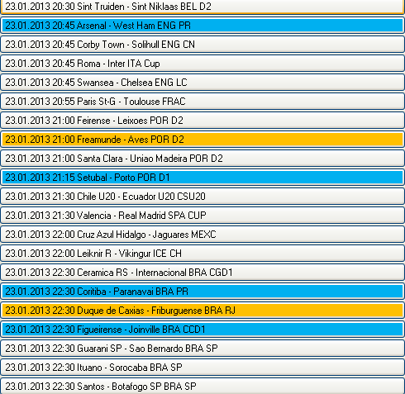
Figure 27: Match list with applied customer defined color schemes

Manual Liveticker Connection
The names of a team on a sport exchange and on a liveticker can differ. Therefore SXTrader has its own mapping table of the names. At every start of SXTrader it will be checked if a new version of that table is available and if necessary updated. Anyway sometimes it happens that a match or a team could not be found in the mapping table. To fix this the user has the possibility to create a local mapping.
To create such a mapping you have to click on match in the match list with missing liveticker connection.
Now the manual mapping dialog opens.
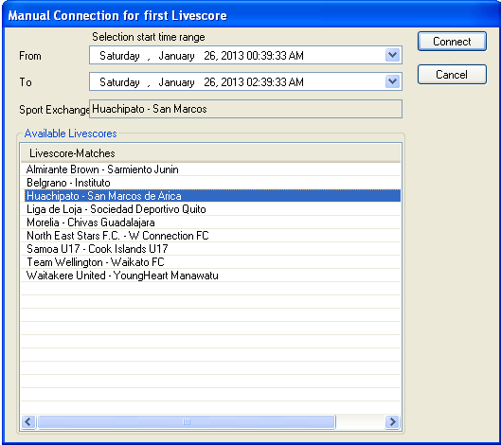
Figure 28: Manual mapping dialog
The title bar of the dialog tells which liveticker should be connected.
With the start time selection you can reduce the list of liveticker connection to those whose start time is withing the selected intervall.
SXTrader is storing manual mappings in a local file for later reuse.
At the text field Sport Exchange the name of the match as it is used at the sport exchange is displayed.
At Available Livescores all matches at the livetickers who are within the selected start time interval are displayed.
If a fitting match has been found the mapping can be confirmed with pressing the button “Connect”.
With pressing “Cancel” the Mapping Dialog is closed and the manual mapping aborted.

View Historic Data
If a match is selected at the match list (and liveticker 1 ist connected) then the historic data of both teams will be loaded. Additionally match will be marked with bold letters in the match list.
Figure 29: Selected Match
The amount and age of the data to load can be defined at the configuration.
The configuration dialog can be called this way:
Menu→Tools→Options→Configuration→Statistics & Analyses→General.
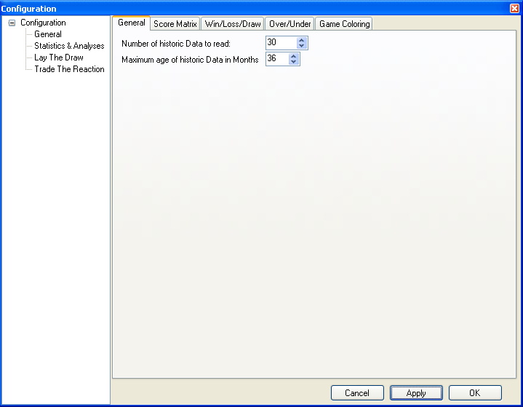
Figure 30: Dialog for setting maximum amount and age of data
The loaded data, if there are any, will be displayed at the historic data view.
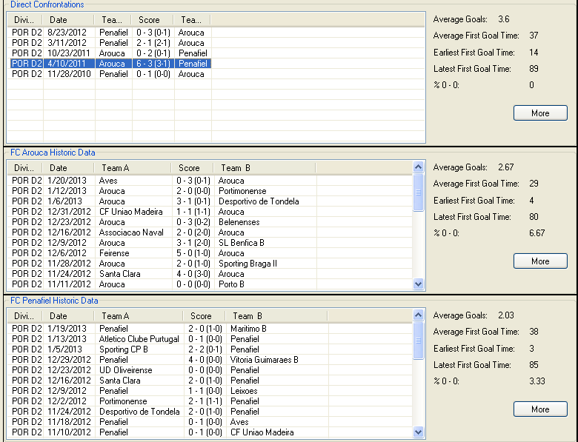
Figure 31: Historic Data View
The view has tree segments. The top segment shows the stored direct confrontation matches. The middle segment the stored matches of the home team. The bottom segment the stored matches of the away team.
Right beside the stored match lists some basic statistics are shown
With pressing the button “More” the Extended Statistics View is loaded.
If a match in the list of stored matches is selected the match detail view will be loaded.

View Match Details
The match details are listing what happened when during a match. Match details contains goals, penalties, owngoals, yellew, red, red-yellow-cards and the name of the respective player.
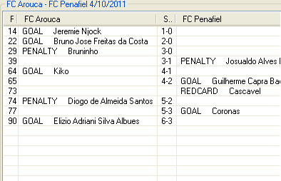
The quality of the match details can greatly vary. Usually at the major leagues all details are given but at minor or excotic leagues and older stored matches ( > 2007) some details might be missing.
Figure 32: View Match Details

View Extended Statistics
If the button “More” is pressed at the view Historic Data then the Extended Statistics will be loaded. It does not matter on which segment of the View Historic Data you press the button because the view Extended Statistics always loads the data for direct confrontation, home team and away team.
The view Extended Data is presenting several statistics in a more graphical way. Here the datablocks could again be preselected by home and away, home, away matches. The label “n=<number>” shows how many datasets where used for the calculation of the statistics.
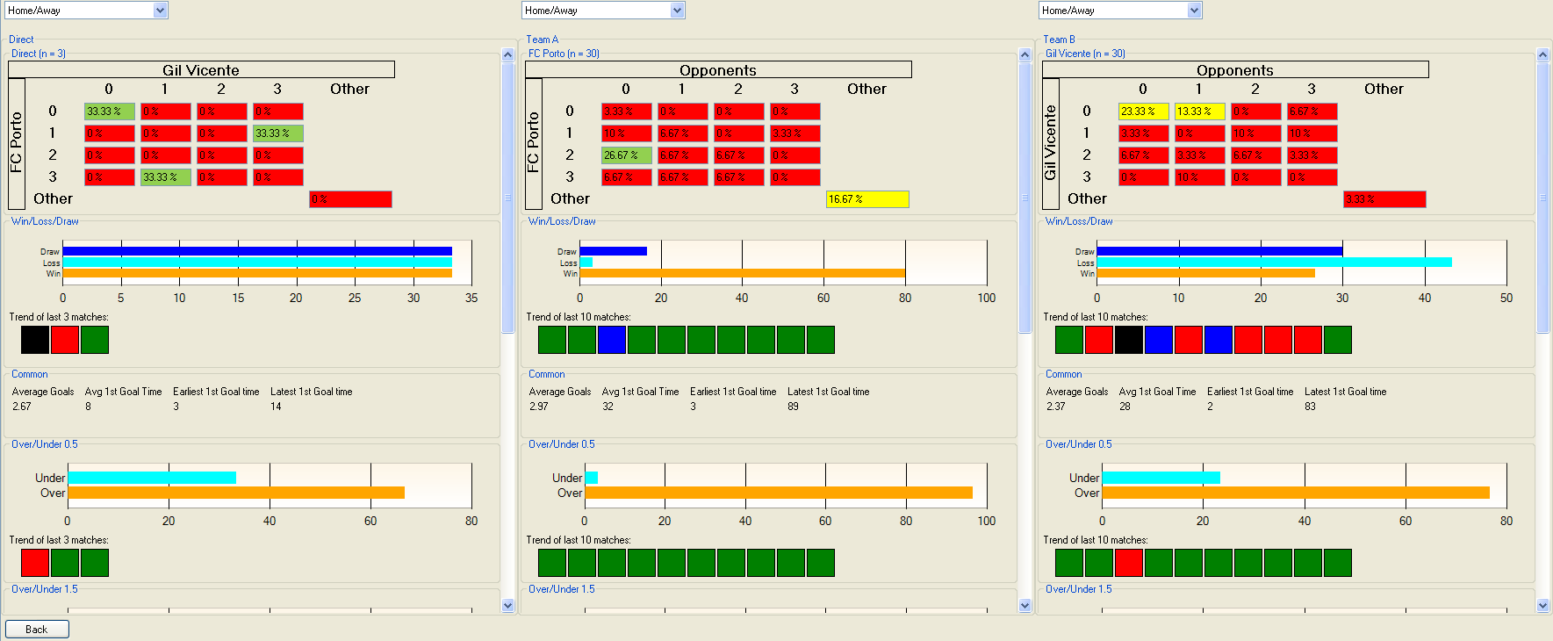
Figure 33: View Extended Statistics

Score Matrix
Purpose of the Score Matrix is to give a graphical presentation of the distribution of the results on the loaded datasets.
The color scheme which color should be used for wich percental range is freely customizable by the user.
The definition dilaog for the colorschemes of the score matrix can be called this way:
Menu→Tools→Options→Configuration→Statistics & Analyses→Score Matrix
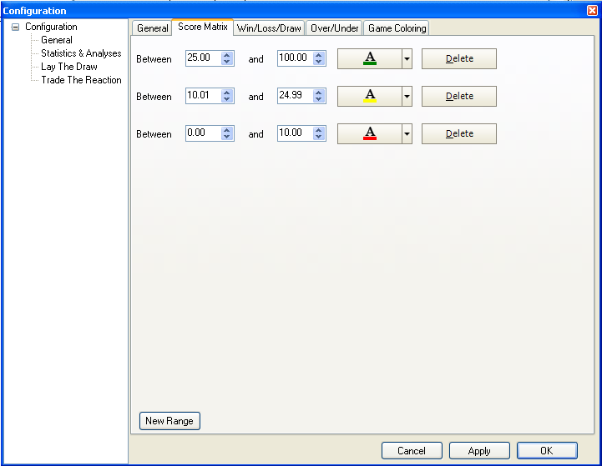
Figure 34: Definition of colorschemes for Score Matrix
A new color scheme is created by pressing the button “New Range”. A color scheme always need a value range for which the choosen color should be valid. With pressing “Apply” or “OK” the color scheme will be saved.

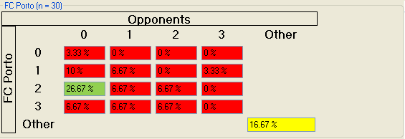
Figure 35: Score Matrix with applied color schemes

Win/Loss/Draw
The Win/Loss/Draw-Display as well as the trend-display over the maximal last 10 is used to give a reprensentation of the match results and the trend in the results in a graphical way.
The color scheme in which value range which color should be used is customizable by the user. The same goes for the colors of the trends
The definition dilaog for the colorschemes of the score matrix can be called this way:
Menu→Tools→Options→Configuration→Statistics & Analyses→Win/Loss/Draw
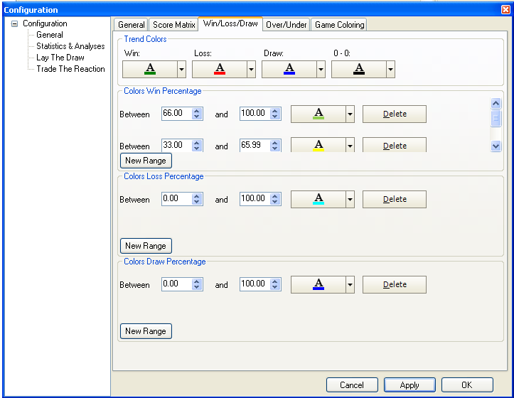
Figure 36: Definition of color schemes for Win/Loss/Draw
At the top segment of that dialog you define the colors for the results which will be used for the trend display. The used possible results for trend are: Win, Loss, Draw and Final Score 0 – 0. Final Score 0 – 0 is used as a separate value for the trend display because for the most ways of trading on soccer markets a Final Score of 0 – 0 ist the worst case situation.
At the following segments are the color scheme definition for the bar diagramm representation of the results. The definition of the values works the same way as described at Score Matrix.
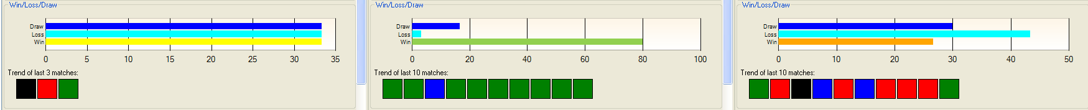
Figure 37: Win/Loss/Draw-Representation and Trends with applied color schemes.

Over/Under
The Over/Under-Display as well as the trend-display over the maximal last 10 is used to give a reprensentation of the goal sum and the trend in the goal sum in a graphical way.
The color scheme in which value range which color should be used is customizable by the user. The same goes for the colors of the trends
The definition dilaog for the colorschemes of the score matrix can be called this way:
Menu→Tools→Options→Configuration→Statistics & Analyses→Over/Under
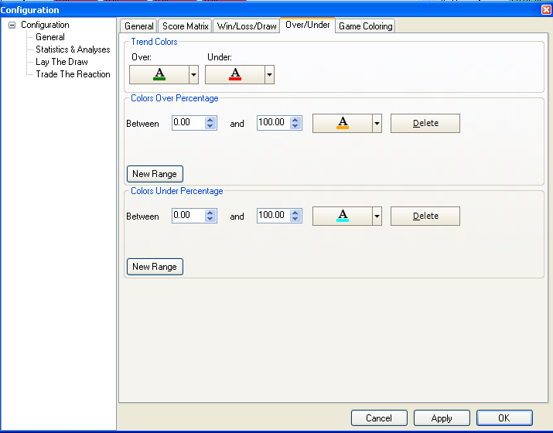
Figure 38: Definition of color schemes for Over/Under
The procedure to define color schemes is the same as described in Win/Loss/Draw.
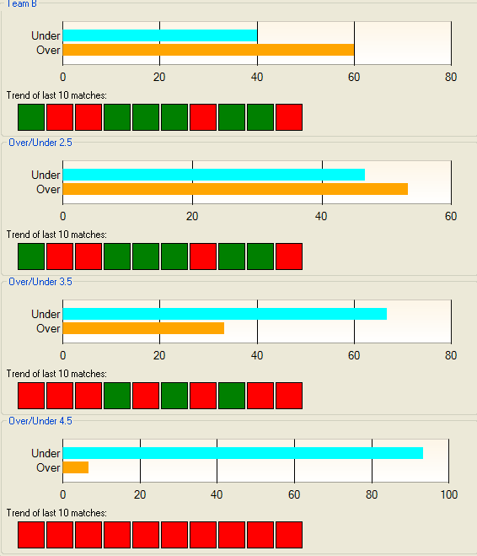
Figure 39: Over/Under-Representation and Trends with applied color schemes.

Liveticker Mapping

